**BILKENT UNIVERSITY  
   
COMPUTER ENGINEERING DEPARTMENT  
   
CS 319 – OBJECT ORIENTED SOFTWARE ENGINEERING  
  
SECTION 03 – GROUP 3D**

**PROJECT TITLE: CASTLE DEFENSE**

**FINAL REPORT  
DRAFT**

**Team Members**  
Xhoana ALIU 21500429  
Muhamed KETA 21503560  
Onur KOCAHAN 21402013  
Mehmet Can ALTUNTAS 21501883

Contents

1.Changes in the Implementation 3

2.Status of The Project 3

3.User’s Guide 3

3.1.Installation 3

3.2.Overview of the Game 3

3.2.1.Game Objects 3

3.2.2.Controls 4

3.2.3.Game Play 4

1.Changes in the Implementation

**User Interface Implementation**: The User Interface subsystem has been changed and it is implemented in order to be more user friendly. The Menu has 6 options and each of the options chosen has its own class implemented.

**View Classes:** We decided to change the View classes a bit since we realized that making some more classes which would correspond to different inputs and outputs would make the game more efficient and faster.

**Save and Load Game:** We decided to implement these two options in a menu bar at the game window since it would make it easier and more accessible for the player to choose between different options.

2.Status of The Project

“Castle Defense” game lacks some features that will be implemented later. These classes and features are listed below:

1. High Scores
2. Animations
3. Sound management (This feature is optional)

3.User’s Guide

3.1. Installation

The game is a desktop application and it is implemented in Java. The game can be installed in any computer that has Java Runtime Environment, therefore the installation is quite easy and these simple requirements for the game installation make the game easily accessible. All in all, everyone who likes our game can install and play it.

3.2. Overview of the Game

3.2.1. Game Objects

3.2.1.1 Tower

Towers will be of different kinds: Basic Tower, Ice Tower, Explosive Tower and Poison Tower. These towers can be bought, sold and upgraded. Each of the towers has different characteristics and different price.

**Basic Tower:** It fires to one enemy when it is fired.

**Explosive Tower:** When explosive tower fires, it gives damage to target creep and the creeps that are in the explosion range.

**Ice Tower:** When ice tower fires, it slows the target creep for slow duration of the tower and creeps gets slower due to slow rate of the tower.

**Poison Tower:** When poison tower fires to the target creep, it gives poison damage per second to the target creep which the poison effect longs due to poison duration of the tower.

   

Basic Tower Explosive Tower Ice Tower Poison Tower

3.2.1.2 Creep

There will be different types of creeps: Speedy Gonzales, Iron Back, Viper and Boss. These creeps will differ from one another due to their strength, speed and health meter. This means that Boss for example will be harder to defeat as its health meter will be greater.

**SpeedyGonzales:** This type of creep can be slowed up to its maximum slow rate.

**IronBack:** It has no peculiar property besides the common properties of creeps.

**Viper:** The poison effect lasts for maximum poison duration of the Viper.

**Boss:** Bosses are harder to kill, which means has higher hitpoint. Also, bosses can be slowed up to its maximum slow rate, be under effect of poison for maximum poison duration of boss and be stunned up to its maximum stun duration.

 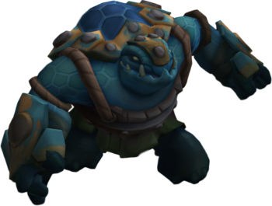 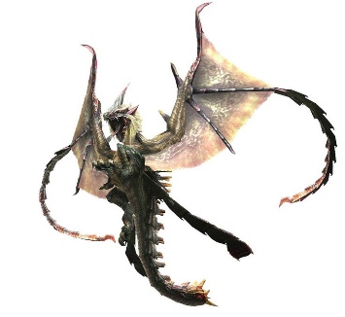  **Speedy Gonzales Ironback Viper Boss**

* + - 1. Consumables

Consumables are of 3 kinds: Stun, Bomb and Glue. They are to be bought during the game and used in order to help in defeating the enemies by using the special characteristics.

**Stun:** It stuns the wave up for its stun duration and once it can be used up to its maximum charge times. Once it is used, it must be recharged. For recharging, the player must kill certain number of creeps.

**Glue:** It slows the wave up to its slow rate for its slow duration. It can be used up to its maximum charge times. Once it is used, it must be recharged. For recharging, the player must kill certain number of creeps.

**Bomb:** It makes an explosion to the player specified position. It gives a damage to the enemy within range of the bomb. It can be used up to its maximum charge times. Once it is used, it must be recharged. For recharging, the player must kill certain number of creeps.

  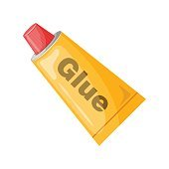

**Stun Consumable Bomb Consumable Glue Consumable**

3.2.2. Controls

The game will use mouse and keyboard as hardware input. The mouse will serve to actually play the game as the player will do everything during the game using the mouse. S/he will select the spots to build her/his towers, choose which tower to build, pick which consumable will use and where will s/he use it with the help of the mouse. The keyboard will be used to insert player’s name in order to keep track of her/his high scores. Also, the ESC key can be used to exit the game besides the red cross on the right top corner of the window.

3.2.3. Game Play

The game’s aim is to defeat all the creeps and not let them surpass the gates to the castle since they are invaders and will destroy it. In order to defend the castle, the player can use some towers which s/he can put along the road where waves of creeps pass. The towers will have different characteristics that damage and eventually defeat the creeps. Together with the towers, the player can make use of the consumables of different types. They also damage the creeps but their effect is not as powerful as the attacks of the towers. A list of player’s high scores will be saved and the player can see her/his progress. Moreover, the user can resume a game s/he has left unfinished by choosing Open Game option in the main menu. It must be highlighted that the maps of the game will be randomly generated so each time the user choses to play a new game s/he will have a new experience which will make the game more interesting and enjoyable.